Day 1 : 21/10/2023

Backend technology -🡪 Java and connecting database using JDBC.

Java

Core Java

J2SE J2EE J2ME

JavaSE JavaEE JavaME

JSE JEE JME

Java Standard Edition Java Enterprise Edition Java Micro Edition

Desktop application Servlet and JSP : web application

Console base application We will teach how to create

Basic Java Programming Rest API

OOPs Concept those rest api we will

Object, call in angular

Class, maven build tools

Exception handling

Collection Framework with Data structure

JDBC topic to connect MySQL

Java8(Lambda Expression and Stream API)

and 11 and 15

Regex

Java 22

Intro to Mongo DB

No SQL Database

Using Java we can connect to database using

1. JDBC
2. ORM -🡪 Hibernate and JPA.
3. Using Core Java, Servlet /JSP we can use JDBC or Hibernate or JPA.
4. Spring Framework we can use JDBC or Hibernate or JPA.
5. In Spring boot JDBC or JPA or Spring Data.

Phase 3 or Course 3

Spring framework and Spring boot

Junit 5 testing tool

Course 4 : Testing and deployment

Testing

TestNG, Selenium,

Docker, CI and CD using Jenkin, Overview of AWS

In AWS we will teach you how to deploy application in EC2 instance using Docker with CI and CD tool ie Jenkin

Frontend -🡪 angular

Backend 🡪 spring boot

Database -🡪 MySQL

Day 2 : 22/10/2023

Java : Java is pure object oriented and platform independent programming language.

Java develop in nov 1995. The initial name of java is Oak.

Version of Java

Java 1.0,1.1,1.2 7, 8,9,11,15 22

Java is an open source.

From java 11 onward java is not open source.

Java was belong to sun micro system

Now it is part of oracle.

Oops

object : object is any real world entity. Example

property or state or variable -🡪 have 🡪 variable, fields etc

name, age, weight, height, colour etc.

int, float, char, double, string etc.

Person

Behaviour or function or methods -🡪 do/does 🡪 function or methods.

Teaching(), sleeping(),talking(), typing(), etc

Bank

Animal

Car

Customer

class : blue print of object or template of object or user defined data type which help to describe the object.

Syntax of class

class ClassName {

fields or variable declaration

method or function declaration

}

class Demo {

main method : pre defined methods.

}

Class name must follow pascal naming

1. If class contains one world first letter upper case.
2. If class contains more than one world each world first letter upper case.

Syntax to write method in java

returnType methodName(parameterList) {

Method body;

}

void display() {

}

Method name is display no passing parameter and no return type.

void add(int x, int y) {

}

Method name is add. We need to pass two parameter of type int but no return type.

String sayHello(String name) {

return “Welcome user “+name;

}

Method name is sayHello. Need to pass one parameter of type string and return string value

In java all method must part of class.

class Test {

public static void main(String args[]) {

System.out.println(“Welcome to Java”);

}

}

Method name and variable name must be follow camel naming rules.

1. If variable name or method name one world. Then it must be in lower case. Like main(), sleeping(), display(), read() etc and id, name,salary etc.
2. If variable name or method name more than one world then from second world first letter upper case like displayInfo(), calSalary(), empId, etc.

Data types : Data type is a type of data which tells what data type data it can hold.

a=10; python

var b=20; js

let c:number =30; ts

datatype variableName;

datatype variableName=value;

In java data types are divided into two types.

1. Primitive data types :it is use to store only value

8 types

1. byte 1 byte -128 to 127
2. short 2 byte
3. int 4 byte
4. long 8 byte

without decimal point

1. float 4 byte
2. double 8 byte

with decimal point

1. char 2 byte in single character
2. boolean 1 bit true or false value

Operator :

1. arithmetic operator : +, -, *, /, %
2. logical operator : &&, ||, !
3. conditional operator : >, <, >=, <=, ==, !=
4. assignment operator =
5. increment and decrement operator : ++, --

if statement

1. simple if
2. if else
3. if else if
4. switch statement

syntax of switch statement

int label =1;

switch(variableName) { variable type must be int, char or string in java.

case 1:block1

break;

case 2:block12

break;

case 3:block3

break;

case 4:block4

break;

default : default block ;

break;

}

Looping : looping is use to execute the task or statement again and again repeatedly

Till the condition become false.

Initialization

Condition

Task

Increment and decrement.

1. While loop : entry loop
2. Do while loop : exit loop
3. For loop

Type casting :

Converting from one data type to another data type is known as type casting.

Two type of type casting.

1. Implicit type casting
2. Explicit type casting

int family

----------------🡪 implicit type casting -----🡪

byte short int long

🡨------------ explicit type casting -------------

int to float implicit

float to int explicit

in java by default every decimal number double consider.

1. Non primitive or reference data types. : it is use to store value as well as reference of another data types.

4 types of non primitive

1. array :array is user defined or reference data type which help to store

same type of values.

In java array is known as fixed in memory size.

datatype arrayname[]; array declaration

int num[];

int a;

int num1[]={10,20,30,40,50}; array declaration with initialization

array memory creation syntax

datatype arrayname[]=new datatype[size];

int num2[]=new int[10];

num2 can hold 10 value. Start from 0 to 9 position.

Taking the value through keyboard in java

Using Scanner class.

Scanner is a pre-defined class part of util package.

Package is a collection of classes as well as interfaces.

We need to create Scanner class object.

Syntax to create Scanner class object

Scanner obj = new Scanner(System.in);

While creating scanner class object we will get error. Because Scanner class part of util

Package. We need to import it.

1. class

Scanner : pre defined class which help to scan the value through keyboard.

String : in Java String is a pre defined class. which help to store more than one

Character in double quote.

String is pre defined class part of lang package.

By default java imported lang package.

1. interface
2. enum

in Ts or JS

class Customer {

}

var obj1 = new Customer();

let obj2=new Customer();

Scanner obj1 = new Scanner(System.in);

obj.nextInt(); int value

obj.next() string value

obj.nextFloat() float value

Day 3 : 28/10/2023

Java OOPs concept

object : any real world entity.

Property or state -🡪 have -🡪 variable or fields.

Person

Behaviour -🡪 do/does -🡪 functions or methods

Bank

Car

Animal

Customer

Employee

class : blue print of object or template of object or user defined data type which help to describe the object.

Method or function syntax

return type methodName(parameterList) {

}

void info() {

coding….

}

Method name is info. For this method we are not passing any parameter while calling

And this method doesn’t return any value to caller method.

void add(int x, int y) {

}

Method name is add while calling this method we need to pass 2 parameter of type int and not return type.

String sayHello(String name) {

Coding

return “Welcome to my method user “+name;

}

Method name is sayHello. We need to pass one parameter of type string and it return string value to caller method.

Fields or variable.

In Java variable or fields are divided into 3 types.

1. Instance variable
2. The variable which declared inside a class but outside method including main method also is known as instance variable.
3. Instance variable hold default value base upon their data types.

Int family 🡪0

Float family 🡪0.0

Char -🡪 space or white space

Booean –> false

String 🡪 null

1. Instance variable we can use all method directly but method must be part of same class and it must be non static.
2. Local variable
   1. The variable which declared inside a method is known as local variable.
   2. Local variable doesn’t hold default value we have to initialize.
   3. The scope of the variable within that method where it declared.
3. Static variable

Constructor : constructor is a type of special method which help to create the object.

Pts.

1. Constructor have same name as class itself.
2. Constructor no return type not even void also.
3. Constructor get call automatically whenever we create the object that class.

class Employee {

Employee() {} in Java Constructor

constructor(){} in typescript or angular

}

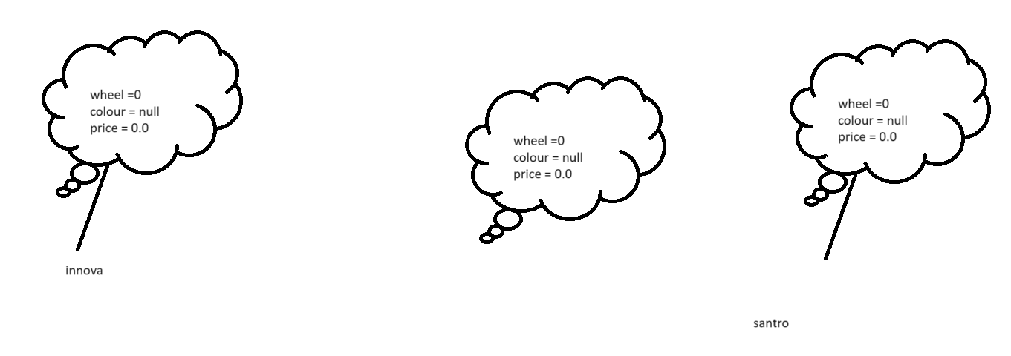

When local or parameter variable and instance variable have same name then local variable or parameter variable hide the visibility of instance variable.

If we want to refer to instance variable this we need to use this keyword. this is a keyword which refer to current to object.

Parameter constructor

Encapsulation : binding or wrapping data or variable and code or method/function is single unit is known as encapsulation.

Example : class.

JavaBean class

Inheritance :

Inheritance is use to inherits or acquire the property and behaviour of old class to new class.

class OldClass { super class or base class or parent class.

property

behaviour

}

class NewClass extends OldClass{ sub class or derived class or child class.

property

behaviour

}

Types of inheritance

1. Single inheritance : one super class and one sub class

class A { }

class B extends A { }

1. Multilevel inheritance : one super class and n number of sub class connected one by one.

class A { }

class B extends A { }

class C extends B { }

class D extends C { }

1. Hierarchical inheritance : one super class and more than one sub class connected directly to super class.

class A { }

class B extends A { }

class C extends A { }

class D extends A { }

1. Multiple inheritance : more than one super class and one sub class

class A { }

class B { }

class C extends A,B { } Java doesn’t support multiple inheritance. Error

this type of inheritance in java we can achieve using interface.

class Employee {

id,name,salary

readEmployee()

displayEmployee();

}

class Manager extends Employee {

numberOfEmp;

readManager()

displayManager();

}

class ProjectManager extends Manager{

clientInfo

readProjectManager()

displayProjectManager();

}

class Developer extends Employee{

techName;

readDeveloper()

disDeveloper()

}

Day 4 : 29/10/2023

Scanner is a pre defined class part of util package.

Outside a class we need to import java.util.Scaner;

Scanner sc = new Scanner(System.in);

System.out.println(“Enter the id”);

Int id = sc.nextInt(); to scan int value

String name = sc.next(); to scan string value but only one world.

String msg = sc.nextLine(); it take more than one world till hit enter key.

float salary = sc.nextFloat();

Polymorphism : one name many forms or many implementation.

2 types

1. Compile time or static binding or early binding

Example : Method overloading :

In C++ Operator overloading is example of compile time polymorphism

The method have same name but different parameter list ie type of parameter list or number of parameter list must be different.

1. Run time or dynamic binding or late binding

Example : Method overriding

The method have same name and same method signature (number of parameter list, type fo parameter list and return type must be same).

To achieve method override we need inheritance.

Annotation : annotation is like a meta data . meta data is data about data.

Annotation is like a decorator in angular.

Java provided lot of pre defined annotation. All annotation start with pre fix @ followed by annotation name. few annotation we can use on class level or method level or property level.

@Override. This annotation we can use on method level of sub class. if sub class method

Overriding super class method then we doesn’t get any error else we will get the error.

Non access specifiers keywords.

Java provide 3 non access specifiers keywords.

1. abstract :abstract is a keyword we can use with method and class but not with variable.
   1. Abstract method : method without body or without curly braces or incomplete method is known as abstract method.

abstract returnType methodName(parameterList);

* 1. If class contains one or more abstract method that class we need to declare as abstract class.

abstract class classname{

}

* 1. Whichever class extends abstract class that class must be provide the body for all abstract method belong to that class mandatory.
  2. Abstract class can contain normal as well as abstract method. Means it can contains zero or 1 or many abstract methods.
  3. Abstract class we can’t create object.

1. final : final keyword we can use with variable, method and class.
   1. final variable : to declare constant value in java we use final keyword.

final int A=10;

A=20; error

* 1. final method : if method is final we can’t override that method. But we can use that method.
  2. Final class : if class is final we can’t inherit that class or extends that class.

1. static : static keyword we can use with variable and method but not with class.
   1. static variable : if variable is static we can access or assign the value of variable using class name.
   2. static method : if method is static we can call that method with help of class name.
   3. we can access static variable using object also as well as we can call static method with help of object also.
   4. Inside non static method we can access both the type of variable directly but inside static method we can access only static variable directly.

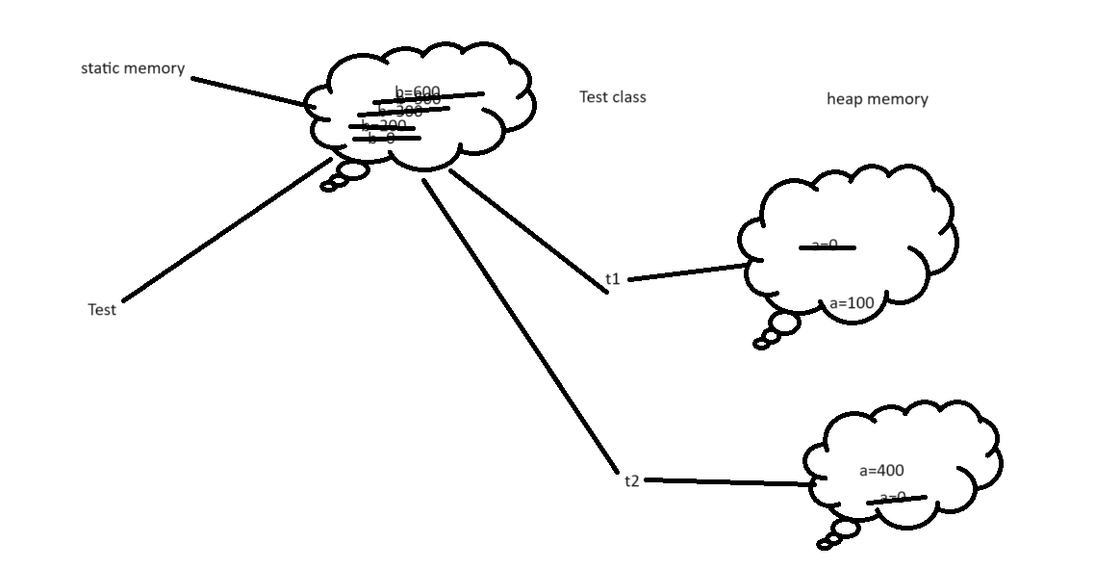

interface : interface is a type of reference data type. It is also known as

100% pure abstract class.

Syntax for interface

interface interfaceName {

variables;

methods;

}

By default all variable inside a interface are public ,static and final.

By default all methods in interface are public and abstract.

interface Abc {

int A=10;

void dis1();

}

interface Xyz {

int B=20;

void dis2();

}

interface Mno extends Abc,Xyz{

int C=30;

void dis3();

}

class Test implements Abc,Xyz {

dis1() and dis2() methods.

}

Like a class one interface can extends another interface as well as interface can extends more than one interface but class can’t.

Class always implements interface. Class can implements more than one interface.

Which ever class implements any interface that class must be provide the body for all those methods belong that interface.

Interface Vs Abstract class.

1. Abstract class can contains normal as well as final variable but interface contains only final variable.
2. Abstract class can contains normal as well as abstract method but interface contains only abstract method.
3. Normal class can extends only one abstract class but normal class implements more than one interface.
4. Abstract class can contains default constructor as well as we can write empty or parameter constructor but interface doesn’t contains any constructor.
5. Using abstract class we can achieve partial abstract but using interface we can achieve 100% abstraction.

Common point we can’t create object of interface as well as abstract class.

Class extends class only one

Interface extends interface more than one

Class implements interface more than one

Interface can’t extends or implements to class.

abstract class Bank {

abstract void withdraw();

abstract void deposit();

void rateOfInterest() {

}

}

Or

interface Bank {

void withdraw();

void deposit();

void rateOfInterest();

}

Package and access specifiers

Package is a collection of classes and interface which have same name but different purpose.

In java package are divided into 2 types.

1. User defined package.
2. Pre defined package.

To create the package we need to use

package packagename;

school college

Attendance Attendance

School student College student

Package is like a directory or folder

Access specifiers

Using access specifiers we can provide the visibility of variable, method and class part of same package or other package.

Java provided 4 types of access specifiers

1. private: we can use this access specifier with what

we can use private with instance variable, static variable, non static method, static method, constructor but not with local variable as well as class.

scope : within a same class.

1. default or nothing : we can use this access specifier with what

we can use with all

scope : within a same package

1. protected : we can use this access specifier with what

we can use private with instance variable, static variable, non static method, static method, constructor but not with local variable as well as class.

scope : within a same class as well as other package if it is sub class

1. public : we can use this access specifier with what

we can use private with instance variable, static variable, non static method, static method, constructor, class but not with local variable.

scope : same package well as other package.

Day 5 : 04/11/2023

Java bean class

1. class must be public
2. all variable must be private
3. for each variable you need to provide setter and getter method.
4. setter set the value and getter get the value.
5. Setter you can write with conditions if you need .
6. If you want provide empty as well as parameter constructor rather than setting value through setter methods.

public class Customer {

private int cid;

private String cname;

public void setId(int cid) {

this.cid = cid;

}

public int getCId() {

return this.cid;

}

}

Pre defined packages.

java javax root package

lang sql

io swing

util servlet

sql ejb

net jms

awt net

etc etc

by default every java program imported lang package.

So we can use all the classes and interface part of lang package without imported

Explicitly

String

System

By default every java program it may be pre defined or user defined internally extends

Object class.

Super API (application programming interface).

Exception handling

Exception is an object or memory which generate when unexpected or abnormal thing happened during the execution of a program.

Using some technique we need to handle generate exception that is known as exception handling.

Java program

Compile program Run the program

javac Demo.java java Demo

compile time error run time error

syntax error

or typo error

after compile program

successfully it generate .class file.

Which contains byte code.

Run time error

Error Exception

In Java Error and Exception both are pre defined classes part of lang package.

Error : The error which generate at rum time which we can’t handle it. JVM crash, software or hardware issue, out of memory.

Exception : The error which generate at rum time which we can handle it. Divided by Zero.

Object

Throwable

Error Exception

Checked Exception Unchecked Exception

RuntimeException

IOException NullPointerException

FileNotFoundException NumberFormatException

SQLException ArrayIndexOutOfBoundsException

Etc ArithmeticException

etc

To handle both the type of exception java provided 5 keyword.

1. try
2. catch
3. finally
4. throw
5. throws

we will handle un checked exception using try catch block

syntax

try {

}catch(Exception e) {

}

Try with multiple catch block

1. try with single catch block : if any exception generate we want to perform common task. Then try with single catch block advisable. In this option is good if we don’t which code generate which type of exception.
2. try with multiple catch block : base upon type of exception we want to execute set of code then we need to use try with multiple catch block. In this option you must be know which code generate what type of exception.

try {

}catch(ArithmeticException e) {

}catch(ArrayIndexOutOfBoundsException e) {

}

finally keyword or block.

try block : the code which may generate the exception we need to keep in try block.

It one line code or more than one line code.

catch block : this block execute if any exception generate. No exception no catch block.

finally block : it is a type of block which will execute 100% sure if any exception generate of not.

try

catch catch catch catch finally

catch finally catch

catch catch

finally

file handing program

database connectivity program

try {

open the file

read and write operation

}catch(Exception e) {

}finally {

Close my resources ie file handling or database connection.

}

throw: throw keyword is use to raise or generate any pre defined or user defined (customer exception) depending upon the conditions.

Syntax

throw new Exception();

or

throw new ExceptionSubClass();

by default every sub class constructor contains super() parameter.

super() parameter is use to call super class empty constructor.

throws : throws keyword we use with method signature to throw the exception to caller method.

void display() throws Exception, ExceptionSubClass {

}

Sleep() method throw checked exception.

If method throw checked exception e need to handle it mandatory otherwise we can’t compile program. Checked exception we can’t avoid we need to handle using try catch or throws mandatory. Unchecked exception can avoid some extends.

So checked exception check twice compile time as well as run time.

Multi threading

Program : set of instruction to perform specific task.

Processor : Processor is responsible to execute the code.

Process : time taken to execute the code or program in execution.

Thread : small execution of a process. Thread also known as light weighed process.

It takes less resource or memory of our machine. Process known as heavy weighted.

By default in java inside a main method default thread execute.

To check default thread details.

Thread t = Thread.currentThread();

Thread is a pre defined class part of lang package which contains currenThread static method which provide default or current thread details.

System.out.println(t); Thread[main,5,main];

Main -🡪 name of the thread

5🡪 priority of the thread

Main 🡪 group of thread

t.setName(“My Thread”);

t.setPriority(1); min 1 and max 10

we can set between 1 to 10 we can’t set less than 1 or more than 10.

Multi tasking :

Task1 ---🡪 welcome to java traininasfasdfasffs

Task 2 -🡪

Task 3 -🡪

Copy and paste

C drive D drive

D drive E drive

E drive F drive

Using process base

Using thread base

Multi tasking using thread base is faster than multi tasking is process base.

In java we can create more than one thread using lot of ways.

1. Using extends Thread class
   1. We need to create normal java class and that class must be extends Thread class.
   2. We need to create Thread class reference or object.
   3. With help of reference we need to call start() method. start() method is a pre defined method part of thread class. which help to start the thread.
   4. Start method internally call run() method. run method present in thread class.
   5. Run method part of thread class which contains empty body.
   6. If we want to do some custom logic we need to override run method and write the custom logic.
2. Using implements Runnable interface.
   1. We need to create normal java class and that class must be implements Runnable interface.
   2. Runnable interface contains one method ie run() method and this method is abstract.
   3. To start thread we need to start method.
   4. But when our class implements Runnable interface we can’t get start() method
   5. So we need create Thread class object and pass the Runnable interface reference. And using thread class reference we can call start() method.
   6. Start method internally call run method

Day 6 : 05/11/2023

Life cycle of thread

create ----🡪 runnable state 🡪 running state ---🡪 stop

obj1 obj1.start() run i = 10

t1 t1.start() run i = 10

isAlive() : check the status of thread

sleep() : to pause the flow the thread

wait() : to suspend the thread

notify() : resume the thread

notifyAll() resume more than one thread.

Task :

Pay the bill

Book the ticket

Transfer the amount etc

Synchronization : it is concept which help to block or lock the thread.

It is use to allow for only thread to use all resources at time.

To use synchronization concept java provided synchronized keyword.

This keyword we can use with method or inside a method we can use more than

Synchronized block.

wait(), notify() and notifyAll()

these three method use to do inner thread communication.

wait() method is make the thread to wait or suspend.

notify() method is use to resume or call back waited thread.

Pts

More than one thread created in same memory and method must be synchronized.

Task t1 = new Task(); Task t2 = new Task();

3 thread we will add 1 thread

Data -🡪 of type number

Consumer need to consume data of any type.

Producer need to produce the data.

Resource class

Resource object we will share to consumer and producer.

Consumer

Producer

Main class

Collection Framework (Data Structure )

Variable

int a=10;

a=20;

array

int abc[]={10,20,30};

structure : it is a type of user defined data type which help to store more than one value of different types.

class Employee {

int id

String name

float salary;

}

Employee emp = new Employee();

emp.id=100;

emp.name=”Ravi”;

emp.salary = 12000.50f;

array object

Employee employees[]=new Employee[100];

employees[0]=new Employee();

employees[1]=new Employee();

employees[99]=new Employee();

int abcd[]=new int[100];

Employee java bean class : id,name,salary, designation

Receive more than one employee details

And base upon designation update salary

If desg is manager 5000 bonus

If desg is developer 3000 bonus

Else

1500

Draw back of array object.

Array is known as fixed in memory size.

If we want to add or remove any data from array it is very complex.

Collection framework provided set of collection of classes which help to store collection of object of any type like int, float , char, double, string or user defined object.

It provided lot of pre defined method which help to add, remove, search, iterate very easily.

Collection framework hierarchy

Collection --🡪 top most interface part of util package.

Set List Queue Map ---🡪 all four interfaces

Set, List, Queue internally extends Collection but map doesn’t extends.

Set : it doesn’t allow duplicate. Set doesn’t provide index position to access the value.

HashSet,

LinkedHashSet

TreeSet

These top classes internally implements Set interface.

List : it allow duplicate. List allow index position

Stack

ArrayList

LinkedList

Vector

These top classes internally implements List interface.

Queue : by default first in first out feature provides

LinkedList

PriorityQueue

Map : it will allow to store information in key-value pairs. Key is unique and value can be duplicate. Using key we can get the value.

HashMap

LinkedHashMap

TreeMap

HashTable

Day 7 : 18/11/2023

HashSet : Unorder

LinkedHashSet : Order

TreeSet : sorting by default asc TreeSet internally implements SortedSet interface that interface provided logic do to sorting.

List API

Stack : Stack is a type of data structure which provide the features

push, pop, peek etc.

ArrayList Vs Normal Array

1. Normal array allow to store same type of values but array list by nature we can store any types of values.
2. Normal array fixed in memory size. ArrayList dynamic memory.
3. Normal array doesn’t provide any method to do some operation. ArrayList provide lot of pre defined method to add, remove, search etc.

**LinkedList**

LinkedList is a type of List API which internally use Node to store the data.

Type of linked list

1. Singular linked list
2. Double linked list
3. Circular linked list

10 null null 10 null

Value ref pref value nref

By default java LinkedList consider as double linked.

1 2 to 100

0 pos 200 ---element in 1 post

LinkedList is good for insertion and deletion

ArrayList is good for retrieve operation

Vector : Vector is a type of legacy class. in Vector by default all method are synchronized.

Thread safe but slow performance.